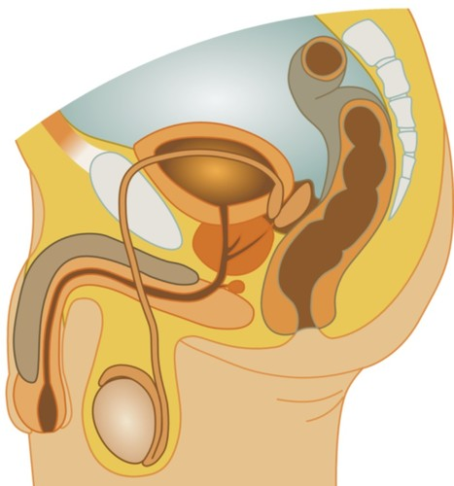
The Male Reproductive System

ORGANS of the Male reproductive system
The purpose of the organs of the male ___________ system is to perform the following ___________:
- To produce, maintain, and ___________ sperm (the male reproductive cells) and ___________ fluid (semen).
- To ___________ sperm within the female reproductive tract during ___________.
- To produce and ___________ male sex hormones ___________ for maintaining the male reproductive system.
THE PENIS
The glans, also called the ___________ of the penis, is covered with a loose layer of skin called ___________. The opening of the ___________, the tube that transports semen and ___________, is at the tip of the penis. The penis also ___________ a number of sensitive nerve endings.
THE SCROTUM
The ___________ pouch-like sac of skin that hangs ___________ and below the penis. It contains the testicles (also called testes), as well as many ___________ and blood vessels.
The scrotum acts as a "___________ control system" for the testes. For ___________ sperm development, the testes must be at a ___________ slightly cooler than body temperature.
Special muscles in the wall of the ___________ allow it to contract and relax, moving the testicles closer to the body for ___________ or farther away from the body to cool the ___________.
THE TESTICLES
The oval organs that lie in the scrotum, secured at either end by a structure called the ______________________.
Most men have two testes. The testes are ___________ for making testosterone, the primary male sex ___________, and for ___________ sperm.
THE EPIDIDYMIS
The epididymis is a long, coiled tube that rests on the ___________ of each testicle.
It ___________ and stores sperm cells that are ___________ in the testes. It also is the job of the ___________ to bring the sperm to ___________, since the sperm that emerge from the testes are immature and incapable of ___________. During sexual arousal, ___________ force the sperm into the vas deferens.

THE VAS DEFERENS
The vas deferens is a long, ___________ tube that travels from the ___________ into the pelvic cavity, to just behind the bladder.
The vas deferens ___________ mature sperm to the urethra, the tube that carries urine or sperm to ___________ of the body, in preparation for ___________.

THE URETHRA
The ___________ is the tube that carries urine from the ___________ to outside of the body. In males, it has the additional ___________ of ejaculating ___________ when the man reaches orgasm.
THE PROSTATE GLAND
The prostate gland is a walnut-sized ___________ that is located below the urinary bladder in front of the ___________.
The prostate gland contributes ___________ fluid to the ejaculate. Prostate fluids also help to ___________ the sperm.
The ___________, which carries the ejaculate to be expelled during orgasm, runs through the ___________ of the ___________ gland.

QUIZ YOURSELF
HOW MUCH DO YOU KNOW?
- Name one of the three purposes of the Male Reproductive System.
- What is the name of the loose pouch-like sac of skin that hangs behind and below the penis?
- What are the oval organs that lie in the scrotum?
- Where is Testosterone made?
- Where can the Epididymis be found?
- Which part of the male reproductive organs is responsible for maturing the sperm?
- Name the long tube that travels from the epididymis into the pelvic cavity, to just behind the bladder.
- What is the role of the Urethra?
- What two organs add to the semen and are located below the urinary bladder in front of the rectum.

